NATURAL LANGUAGE PROCESSING (NLP)



Natural language processing strives to build machines that understand and respond to text or voice data—and respond with text or speech of their own—in much the same way humans do.

Natural language processing (NLP) refers to the branch of computer science—and more specifically, the branch of artificial intelligence or AI—concerned with giving computers the ability to understand text and spoken words in much the same way human beings can.

It combines linguistics – rule based modeling of the human language with machine learning and deep learning models about which we have studied earlier as well. Together these technologies enable computers to process human language in form of text or voice data and to ‘understand’ its meaning.

Example – have you ever used an alexa to talk to it and give commands to it? It works on the same basis.

Another example is voice dictation in which you speak and the mobile or computer keeps typing what you say.

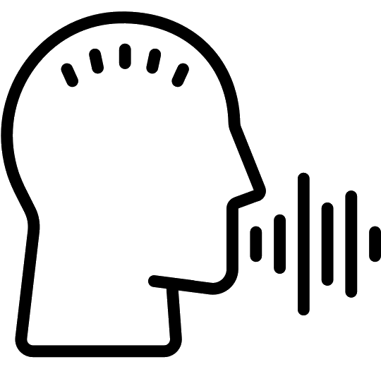



Try playing this game

<https://experiments.withgoogle.com/mystery-animal>

Try playing Semantris on - <https://research.google.com/semantris/>

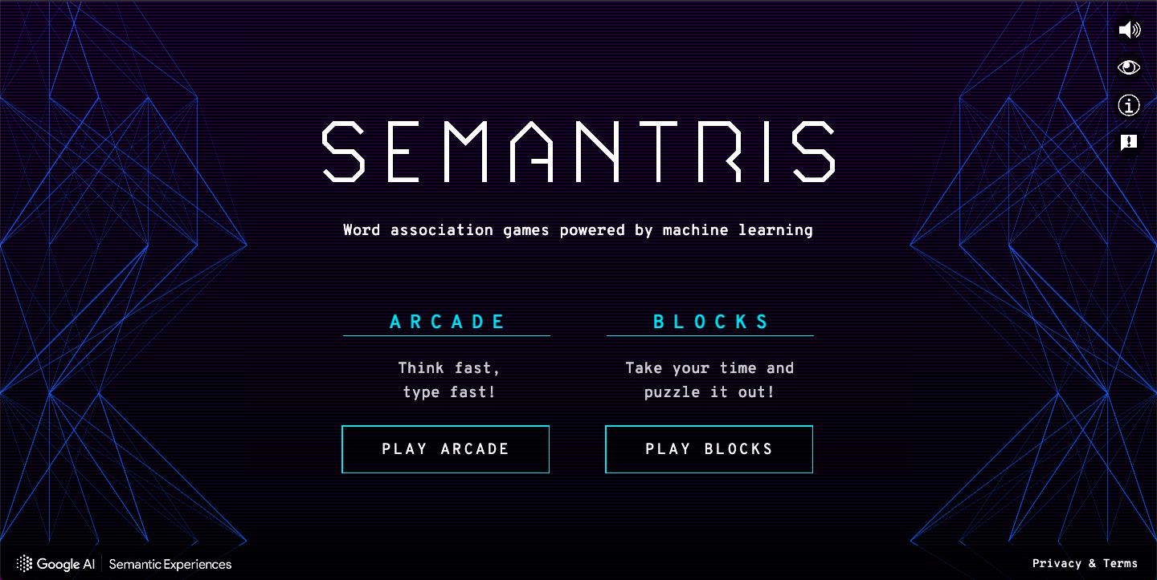

* APPLICATIONS OF NATURAL LANGUAGE PROCESSING (NLP)

1. Search Autocorrect and Autocomplete

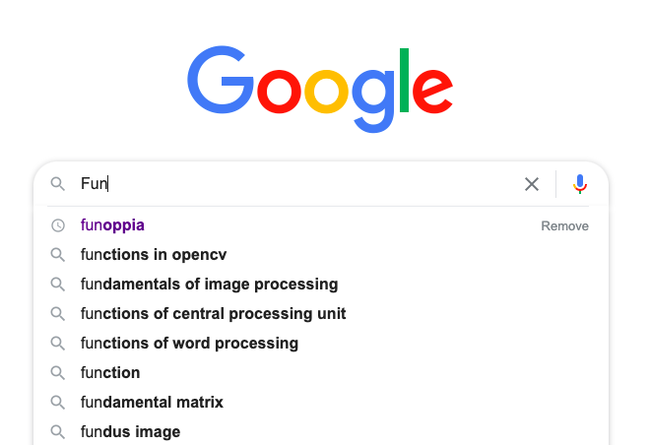

Whenever you search for something on Google, after typing 2-3 letters, it shows you the possible search terms. Or, if you search for something with typos, it corrects them and still finds relevant results for you. Isn’t it amazing?

Search autocomplete and autocorrect both help us in finding accurate results much efficiently. Now, various other companies have also started using this feature on their websites, like Facebook and Quora.

1. Language Translator

Have you ever used Google Translate to find out what a particular word or phrase is in a different language? I’m sure it’s a YES!! and the ease with which it translates a piece of text in one language to another is pretty amazing, right? The technique behind it is Machine Translation.



1. Automatic Summarization



Information overload is a real problem when we need to access a specific, important piece of information from a huge knowledge base. Automatic summarization is relevant not only for summarizing the meaning of documents and information, but also to understand the emotional meanings within the information, such as in collecting data from social media.

1. Chatbots

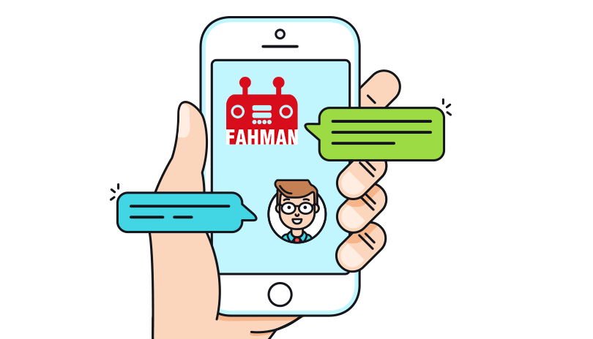

Customer service and experience are the most important thing for any company. It can help the companies improve their products, and also keep the customers satisfied. But interacting with every customer manually, and resolving the problems can be a tedious task. This is where Chatbots come into the picture. Chatbots help the companies in achieving the goal of smooth customer experience.

1. Virtual assistants

Nowadays Google Assistant, Cortana,

Siri, Alexa, etc have become an integral part of our lives. Not only can we talk to them but they also have the abilities to make our lives easier. By accessing our data, they can help us in keeping notes of our tasks, make calls for us, send

messages and a lot more. With the help of speech

recognition, these assistants can not only detect our speech but can also make sense out of it. According to recent researches, a lot more advancements are expected in this

field in the near future.

